Human Evolution
Australopithecus | Homo Habilis | Homo Erectus | Homo Antecessor | Homo Heidelbergensis | Neanderthal | Homo Sapiens
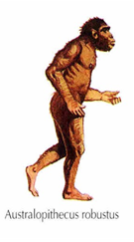 | 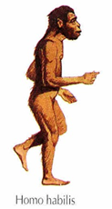 | 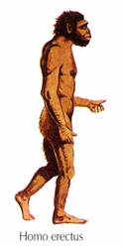 | 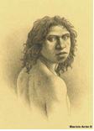 | 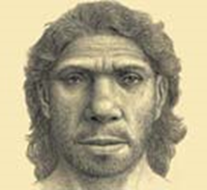 | 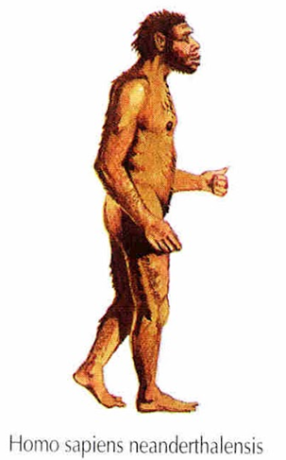 | 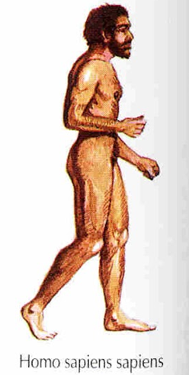
4 million –  2 million years ago | 2,3 million – 1,8 million years ago | 1,9 million -400.000 years ago | 1,2 million years - 800.000 years ago | 600.000-200.000 years ago | 230.000 – 28.000 years ago | 130.000 years ago (40.000 years ago in Europe) – Till now
He was one of the first hominids.  He was one of the first that walked upright. | First homo  First tools  He could speak | Discovery of fire  Hunted in groups  He was the first homo that left Africa and went to Asia and Europe | First European (probably)  Ancestor of the Homo Heidelbergensis and  Homo Neanderthalensis | He lived in Africa, Europe and Western Asia  Neanderthals, Denisovans and Homo Sapiens descend from him. | He lived in Europe and Middle East  First burials  Specialised tools  He was adapted to cold climates because he lived in the Ice Age. | First examples of art  Very specialised tools  Smaller tools and also tools made of bone and horn.  It’s our own species
Human Evolution
 |  |  | Homo Antecessor | Homo Heidelbergensis
 |  | 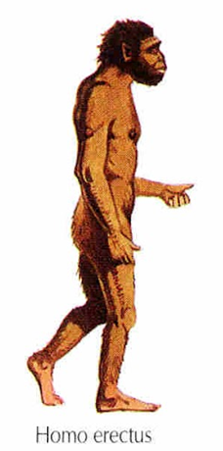 | 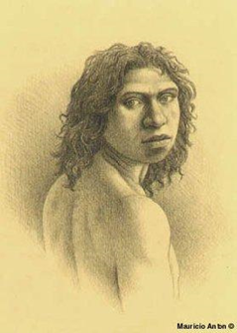 |  | 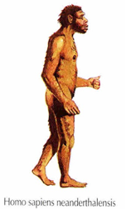 | 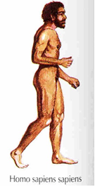
 |  |  | 1,2 million years - 800.000 years ago | 600.000-200.000 years ago
 |  |  | First European (probably)  Ancestor of the Homo Heidelbrgensis and  Homo Neanderthalensis | He lived in Africa, Europe and Western Asia  Neanderthals, Denisovans and Homo Sapiens descend from him.

Fill the columns with the correct information
Homos | Dates
- Homo Habilis  - Homo Sapiens Sapiens  - Homo Erectus  - Homo Sapiens Neanderthalensis  - Australopithecus | o 1,9 million -400.000 years ago  o 130.000 years ago (40.000 years ago in Europe) – Till now.  o 4 million – 2 million years ago  o 2,5 million – 1,8 million years ago  o 230.000 – 28.000 years ago
Characteristics
o Specialised tools
o Discovery of fire
o He was the first homo that left Africa and went to Asia and Europe
o First examples of art
o First tools
- He was one of the first hominids and his main characteristic is that he walked upright.
o Hunted in groups
o Smaller tools and also tools made of bone and horn
o First burials
o He could speak
- Very specialised tools
- He was adapted to cold climates because he lived in the Ice Age.
- It’s our own species
- First Homo

