STRUCTURES

Index
1 Definition
2 Our main rival: forces
3 Fighting resistance: the structures

3.1 Stability

3.2 Strength or resistance

3.3 Rigidity
4 Types of structures

4.1 Massive structures

4.2 Arches, vaults and domes

4.3 Framework structures

4.4 Truss structures

4.5 Bridges
5 Foundations.
6 Form and Function.
7 Activities
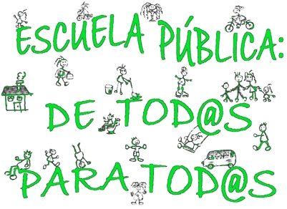

Definition

Let’s look at the etymology (the study of the origin of words) of structure: Structure (latin structūra) is the arrangement and order of the parts within a whole.

The elements that are important within a structure are its disposition (location and placement) and the order in which they are found.

We can talk about structure with almost all things.
For example , the structure of a class is composed of the students, the professor, the chairs, the tables, chalkboard and most importantly the formation in which they are placed.

Remember that when you are 4 or 5 years old the chairs and tables in your classes are not arranged in the same way that they are in high school. The way in which chairs and tables are arranged is related to the kind of work that is done in a classroom. In the same way, how we place the elements (disposition) and the order that we put them together will influence the way of working.

On this unit we will focus on the structures, whose main function is to resist physical forces. Our opponent in this “fight” is physical force.
The first thing we need to do in order to to win this fight is to understand what kind of pressure it is under and how to construct structures that are capable of resisting force.

Our main rival: forces
All objects in the universe are under various types of forces.We can define force as everything that is capable of modifying the state of rest or movement of a body (including deformation).
These forces can be classified according to its duration:
- Fixed or permanent: always present and the structure will always support the force at all times. For example: the weight of a building, body of a trunk.

- Variables or intermittent: appear or disappear depending on external conditions to the structure. For example: the action of the wind, snow.

Another important classification of different forces is depends on how they work.
- Static forces: the variation of the intensity, place or direction in which strength doesn´t change in short periods of time. For example: the weight of a building, snow.

- Dynamic forces: the forces acting on the structure suddenly change value, place of application or direction. For example: earthquakes, sudden impacts.

Dynamics forces are very dangerous for structures. In areas of the planet where there is a higher risk of earthquakes, it is important to calculate the resistance of the structures in order to prevent destruction of structures during an earthquake event.

With our rival, force, it is important to know two things:
- the force value (if very large or very small)
- the place where force is being applied

Sometimes the place is more important than the value.To check you can do the following experiment:
With a single arm, try to lift up a classroom chair for as long as you can. First with the arm fully extended and then with the arm next to the body.
The weight of the chair and therefore the force (permanent) of the chair (due to the gravity of the earth which attracts toward its center) is the same in the two cases. But its effect on the structure, which in this case is our body, is very different.

What you have just experienced is called calculation of structures: moment of a force is the physical quantity that is used to calculate the effect of a force, taking into account the place where is being implemented.

Perhaps you are wondering why this happens. The answer is not simple. We might just say that this is the way it is on our planet and in the universe in which we live. But it is not necessary to think that the moment of a force is an obstacle or a problem. It is the exact opposite. We can make use of the moment from the forces in our favor to lift the biggest weights with less effort. More than 2000 years ago, the scientist Arquímedes said that it would be possible to move the whole world if he had a point of support.

The simplest form to apply the characteristic of the moment of the forces is by means of a lever. In the example, you can see 2 kg mass. It can be in balance with other one of 10 kg simply because that 2 kg is removed 5 meters (2 kg x 5m = 10 kg m) and that 10 kg is removed from the point of support (fulcrum) only1 meter (10 kg x 1m = 10 kg m). Two forces produce 10 kg moment m.
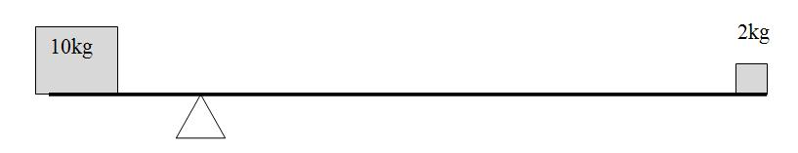

Fighting resistance: the structures

We can do a classification of structures in:
- Natural: have been "made" by nature thousands of years ago by evolution. For example: skeleton, shell of a crustacean, trunk and branches of a tree.

- Artificial: are created by human beings. For example: beams of a building, a table, a bridge, a crane.

The conditions that must meet a structure are:

A. Stability (that doesn't tip over)
B. Strength or resistance (that doesn’t break)
C. Rigidity (that is not deformed)

Stability

An object is much more stable the closer the center of gravity is to the ground and the larger the base, the more stable the object will be.

The center of gravity has a lot to do with what we call moment of forces.The less distance from the center of gravity to the center of the structure makes it easier for the structure to resist it force. Something that you can apply in your daily life.

In order to have stable structures, we must focus on the masses and bring them closer to the ground, some solutions to bring stability to a structure:

Strength or resistance

A structure is resistant when it is capable of enduring, or supporting, the efforts to which it is subject.
Logically the efforts responsible are the forces and the moments of those forces. When the forces act on structures there are different production efforts: tension, compression, bending, torsion and shear. We are going to study a little more in detail each of these forms in which forces are acting on structures.

Types of Efforts or stress:
- Tension or traction (to stretch)
- Compression (to compress or smash)
- Bending or flexibility (to curve or bend)
- Torsion (to twist)
- Shear (to cut)

Tension or Traction: consists of two equal forces in the same direction and move in opposite ways that stretch the object. Examples: Slingshot, hanging object, rope pulled by two ends.

Compression: consists of two equal forces that move in the same direction and move in the same way that tend to reduce the length of the object. Examples: Column, a table leg, tighten a ball.

Bending or flexibility: forces that tend to bend the object. Flexion produces compression in the concave part of the element and pull in the opposite, the convex. Examples: shelving, bridge, beam.

Torsion: forces that tend to twist the object. Example: to drain a cloth.

Shear: two forces applied in contrary ways almost in the same vertical tend to cut the object. Example: scissors.


Rigidity

To achieve the rigidity of a structure (which is not deformed), the profiles must form triangular cells. Cables, bars and braces can be used for this purpose.
A structure is made up by 4 bars that is easily deformable.
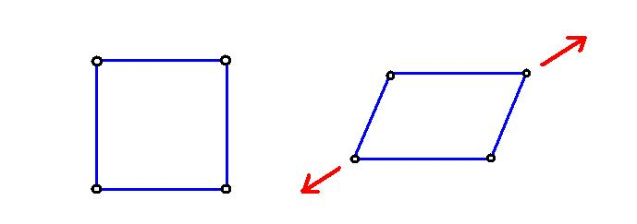

However, a structure composed of 3 bars may not deform and for this reason most of the metal structures are composed of triangular structures.
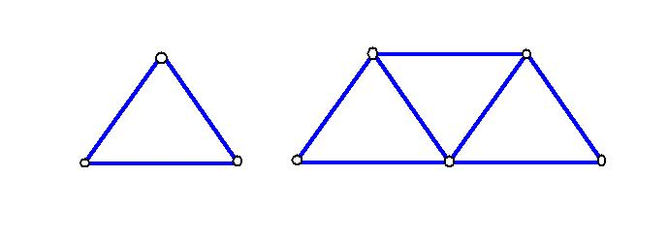
Doesn’t deform Doesn’t deform

Trussing: method to obtain more rigid structures which consists of making triangular structures.
Trussing gives rigidity to the structure. As you can see in the following image the triangulation prevents deformity. The central bar prevents that the structure from deforming.

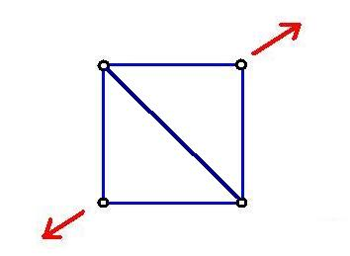

Types of structures

To describe the different types of structures will take advantage to learn some essential structures. This short list does not include all structures, only those that are are essential. We cannot live without know them. We are not going to pretend that they are necessary to breathe, but it is important to know about them and how significant they are to our way of life.

Massive structures
They are made using heavy elements: stones, clay, wood, and just have gaps. Those elements make up work to compression.
Examples:

Pyramids of Egypt Pyramid at Teotihuacan, Mexico

Arches, vaults and domes
Its elements work by compression. Its main purpose is to cover a space between two walls in the case of the vaults or between 4 or more of the domes.
Examples:

(Arch) Aqueduct of Segovia, España (Dome) Pantheon, Rome, Italy
Examples of vaults:

Framework structures
They combine elements as the beams, pillars and columns. Of wood, steel or concrete.

- Pillars: Resistant elements arranged in a vertical position, which support the weight of the elements that rest on them. When they are in a cylindrical form they are named columns.
- Beams: Elements placed normally in horizontal position that support the load of the structure and transmit towards the pillars.

Parthenon, Atenas, Grecia Temple of Karnak, Egypt

Villa Saboya,
Paris, France

Truss structures
Often we find structures that are formed by a set of profiles grouped geometrically that form a network of triangles and are called trusses. They are seen in industrial construction, cranes, electricity pylons, removable grandstands etc.

Eiffel Tower, Paris, France United States Pavilion, Montreal Expo 1967

Bridges

Suspension Bridge, Golden Gate, San Francisco Suspension Bridge, El Alamillo, Sevilla.

Stone Bridge, Puente Romano, Merida Bracket Bridge, Railway Bridge, Forth.

Foundations.
We have studied the different types of forces, the efforts that these forces produce on the structures and the form at which the structures are employed to resist. But, what happens with the structures that suffer under these efforts? What ends up taking all the efforts that support the structures and therefore resisting all the forces and the moments of the same ones? The answer is: THE GROUND.
The ground is our tough ally. The structures are a mere transmitter of the forces from the place where they originate until they come to the ground. This is almost always like that, there are very few cases in which the structures do not unload its heavy charges in the tough ground. For example, this does not happen with planes, but there are exceptions. It is fundamental that the transmission of effort on the structure and the ground is done effectively. It is important to realize that the function of these structures in most cases are used as the foundation, which will be the part of the structure entrusted to transmit the forces to the ground distributing them in a best possible way.
Remember when we studied the force produced by the moment we lifted the chair? Oddly enough, the floor was actually what ended up supporting the weight of the chair. Through traction, compression and bending of our arm and other muscles and bones, our body supported the weight of the chair. As you can imagine, not all ground has the same capacity to absorb the forces transmitted to them and the structures. Therefore, it will be important to adapt the foundations to the type of land on which the structures are built.

Form and Function.

During this entire topic, we have been talking about structures from a practical point of view. What we wanted to understand was if the structure fulfilled its function and which one could stand all the efforts that the forces produced on them. Also, could the structure stand effort and force without deforming the structure with the least amount of material possible?

But a simple look at everything around us makes us see that there is something more. On one hand, we see structures like electicity pylons that fulfill their role with the minimum amount of material. But on the other hand, we see many structures with shapes and designs that are not directly related to its function. The passion for beauty and aesthetics is something that has driven humankind since the beginning and structures and a good opportunity to develop beauty in our society.

Do you think the structure and form of the Guggenheim Museum in Bilbao is constructed simply to meet its function? Of course not. There are much simpler and cheaper ways to cover a space that is destined to be a museum. Was it a mistake to construct a structure as special and expensive as the Guggenheim Museum in Bilbao? In this case, the answer is also no. From an economic point of view, the Guggenheim Museum has been a success and has created great wealth in Bilbao. For example, the construction of the Bilbao Museum has considerably increased the number of tourists to the city. From an aesthetic point of view, the museum’s design has been accepted as one of the symbols of a new and more modern Bilbao, helping to regenerate an entire area of ​​the city that was destroyed by industries along the river.

Activities
- What is force?
- Difference between permanent and variable loads or forces. Put two examples of each.
- List four loads or forces that can act on a building. Describe what are fixed and which variables are acting on this building.
- What is a structure?
- List 3 natural structures and 3 artificial ones
- List the most common types of efforts and explain what occurs with each one and give an example of each. Draw a chart like the following in your notebook and complete it.
Types of Effort/Stress | Drawing and explanation | Example
… | ... | ...

- Indicate what kind of efforts are affecting the elements of the following structures

- Analyze the items shown in the following structure and describe what kind of effort is shown.
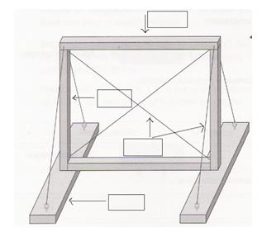
- In each of the following objects, describe what kind of effort are subject:

Key to open a door Cut paper with scissors
Cable with hanging lamp Ssocks
Foot of a chair Shelf Divider
Fishing Line Saw (used to cut wood)
Point of Screwdriver A column

- Which of these structures does not deform by applying a force on its vertex?
Draw what you would get when the 3 other structures don´t deform.

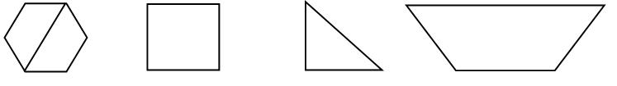
- Which of the following structures is more stable? And the most unstable? Briefly explain
- the most stable. Why?
- the most unstable. Why?
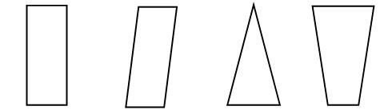

- Types of artificial structures. Draw a chart like the following in your notebook and complete it.

Structures | Materials Used

- Which of the following structures, write the side if they are a massive, arched, framework, truss or hanging (bridge).

Shopping Mall Aqueduct of Segovia
Stone Wall Bridge of Catenaria
Crane Ancient Cathedrals
High Voltage Tower Ferris Wheel
Apartment Building Dam on a reservoir

